
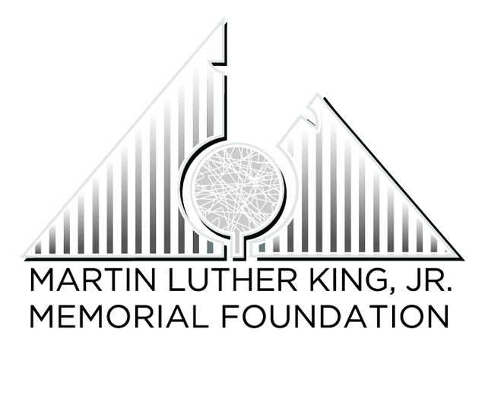

2022

Dr. Martin Luther King, Jr.

Dream Keeper Scholarship Awards

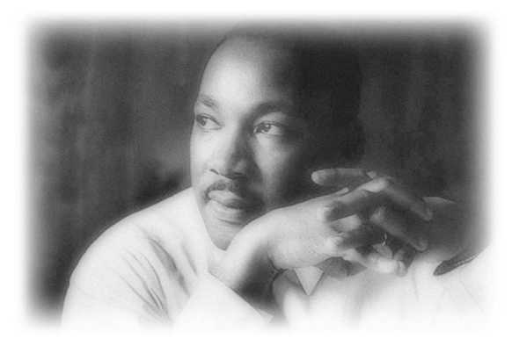

Recognizing Community Involvement, Social Responsibility and Human Service

“We must remember that intelligence is not enough. Intelligence plus character—that is the goal of true education.”
—Dr. Martin Luther King, Jr. “The Purpose of Education”
Applications must be returned to the City of Columbia Parks and Recreation Department, 1111 Recreation Drive, Columbia, SC 29201. Entries must be postmarked by Friday, December 17, 2021

For more information, please contact Kevin B. Crawford, public and media relations manager, at 803-545-0041 or Kevin.Crawford@columbiasc.gov.

2022 MLK Dream Keeper Award

The Dream Keeper Award was established by former Councilman E.W. Cromartie, II. The award recognizes exemplary displays of committed service to the tenets of Dr. Martin Luther King, Jr. The ideals of social responsibility, political empowerment, diversity, racial harmony, nonviolence, and unselfish service must be demonstrated voluntarily by the nominee in support of his or her community and fellow citizens.

Nomination Criteria
1. Demonstrated public service
The nominee must have provided extraordinary assistance to a resident or agency within their community. Through documented work with volunteer work programs, charitable service, and/or leadership roles in the community, the nomination letter should include details of the nominee’s service.
2. Nominee’s effectiveness
An evaluation of the nominee’s effectiveness shall be judged by his or her impact on individuals, groups, or organizations served. The nominee must have demonstrated a constant drive and aspiration to provide support to others in the community for at least 12 months.
3. Documentation
Nominations must include comprehensive documentation of the candidate’s public service contribution. The nomination should include a statement of 150 words or less explaining the nominee’s community service activities.
4. Requirements
The nominee must be age 18 or younger and enrolled in a grade school (elementary, middle or high school) with a minimum 2.0 grade point average.

NEW GUIDELINES:
- If chosen as a winner, the student cannot apply for another scholarship until he or she has entered another category grade level (elementary, middle and high school). For example, if you apply for a scholarship while in elementary school, you cannot apply again until you reach middle school. If you win in middle school, you cannot apply again until you reach high school.
- To be eligible for the $1,000 scholarship, high school students must have a 3.0 GPA or higher.

The award recipients will be selected by an impartial host of judges. Scholarship winners will not be selected by City of Columbia staff or the Martin Luther King, Jr. Memorial Foundation Planning Committee.

Scholarship Levels

High School Awards (9-12) 500 words: 1st place- $1000, 2nd place- $500, 3rd place- $250

Middle School Awards (6-8) 250 words: 1st place- $250, 2nd place- $175, 3rd place- $100

Elementary School Awards (k-5) 100 words: 1st place-$100, 2nd place- $75, 3rd place-$50

Dream Keeper Scholarship Nomination Form

Nominee Information
PLEASE PRINT
Name: _________________________________________________________
Address: _______________________________________________________
Home phone: ______________________
Grade Level: ______ Name of School: ________________________________
Parent Name: ___________________________________________________
Home phone: _____________Work _______________Cell _______________
Email: ________________________________________________________

College/University Information (if applicable)
Name of Institution | Accepted | Applied | Pending | Intended Major
Nominator Contact Information:

Name: _______________________________________________________

Address: _____________________________________________________

City ____________________________________ State ________________

Home phone: ________________ Work: ________________

Email: ________________________________________________________

2022 MLK Dream Keeper Scholarship Checklist

Please review the following checklist to make sure that your application is complete. The following items must be included in the application packet:

- The nomination form from page 3 of this application. Please print required information.
- A statement of 150 words or less from nominator explaining the candidate’s volunteer service, most outstanding achievement, and contributions made to his or her community.
- Documentation of public service to include certificates, volunteer log, letter from organization documenting service, etc. Please list all memberships in community organizations, honors and awards.
- A transcript from your school or school report card noting grade point average or grades.
- A letter of recommendation from personnel from the applicant’s school or community organization. The letter must explain why this candidate should receive the Dream Keeper Scholarship Award (Signed letters of recommendation must be given to the applicant in a sealed envelope to be included in the completed application package.)
- A short essay (100-500 words) describing how you have attempted to emulate or mirror the ideals and philosophies (social responsibility, political empowerment, diversity, racial harmony, nonviolence, and unselfish service) of Dr. Martin Luther King into your life.

Nominations must be postmarked by Friday, December 17, 2021, in order to be eligible. Mail nominations to:
City of Columbia Parks and Recreation Department
Attn: Kevin B. Crawford II
1111 Recreation Drive
Columbia, South Carolina 29201

The award recipients will be selected by an impartial host of judges. Scholarship winners will not be selected by City of Columbia staff nor the Martin Luther King, Jr. Memorial Foundation Planning Committee.

